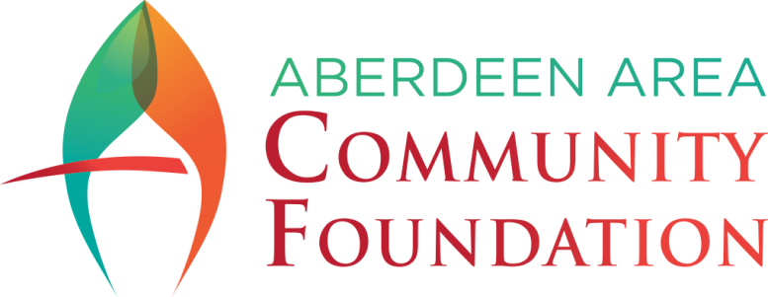

Grant Request Application
Please fill out the application completely
to be considered for a grant.

Organization Name:
Are you a 501(c)(3) nonprofit? |  |  |  | Yes No
Is your organization a public agency/unit of government/school/church? |  |  |  |  |  |  |  | Yes No
What is your EIN?
Address:
City |  |  |  |  |  | State |  |  |  | Zip
Contact Name
Title (If Applicable):
Phone: | ( ) |  |  |  | Alternate Phone: |  |  |  | ( )
E-mail Address:

Please check if this application is for the Aberdeen Energy Agriculture Fund.

Briefly Describe Your Non-Profit Organization:

Briefly describe your project:

Beginning Date of Project: |  | Ending date of Project:
Amount of Request: |  | Total Project/ Program Cost:
(Include funding from other sources)

1. Please Provide a Detailed Description of the Project:

2. Describe the Need for this Project including its potential impact:

3. Please articulate how your project aligns with the mission of the Aberdeen Area Community Foundation (AACF):

4. Does this project involve partnership with other agencies or organizations? If yes, list the names of those agencies or organizations:

5. Please include detailed project budget information. You may provide your own budget or use the template below. Identify other donors and partners and their contribution amounts. Include administrative, operational, promotional, and other costs. The budget must indicate how the Aberdeen Area Community Foundation funds will be spent and over what period of time.

Project Period: From |  | To

PROJECT COSTS: | TOTAL | YOUR ORGANIZATION FUNDS | FUNDS FROM OTHER SOURCES | AACF FUNDS
Administrative
(Include salaries, benefits,
other personnel expenses)
Operational
(Supplies, equipment, daily
expenses items)
Promotional
(Fund raising, advertising,
marketing expenses)
Other Costs
(Please describe)
TOTALS

6. Have you submitted a proposal for these funds to any other granting source?
If yes, please indicate the amount: $
If no, please explain:

7. Briefly outline your plan for evaluating the success of the project and reporting back to the Aberdeen Area Community Foundation. Please include how you will measure impact, collect feedback, and share results. By signing this application, you agree that AACF may share your project results.

8. Sustainability – Describe the project continuation plan and the probability of continued support:

9. Promoting and advertising the Aberdeen Area Community Foundation after receiving a grant is not only a gesture of gratitude but also a way to raise awareness of the AACF and potentially attract further support in the future. In signing this application, you agree to actively promote the AACF’s support. Here are several ways grantees can promote the Aberdeen Area Community Foundation:
- Acknowledgment in Communications: This could include press releases, newsletters, social media posts, and website updates.
- Public Recognition: Acknowledge the AACF during public events, presentations, or speaking engagements related to the project. This can be done verbally or through visual displays, such as banners or slideshows.
- Media Outreach: Share success stories or updates about the project with local or industry-specific media outlets and include mentions of the AACF’s support.
- Website and Online Platforms: Create a dedicated section on your organization's website highlighting the AACF’s support or utilize social media platforms to share posts recognizing the AACF and tagging our official accounts.
- Collaborative Content: Collaborate with the AACF on content creation, such as blog posts, articles, or videos, that showcase the impact of the funded project and the AACF’s contribution.
_________________________________________
Print Name and Title

_________________________________________
Signature

_______________________________
Date

SUBMISSION
Please send this application, along with all requested supporting documents, to:

Aberdeen Area Community Foundation, Inc.
PO Box 674
Aberdeen, SD 57402-0674
or email it to info@aberdeencommunityfoundation.com

